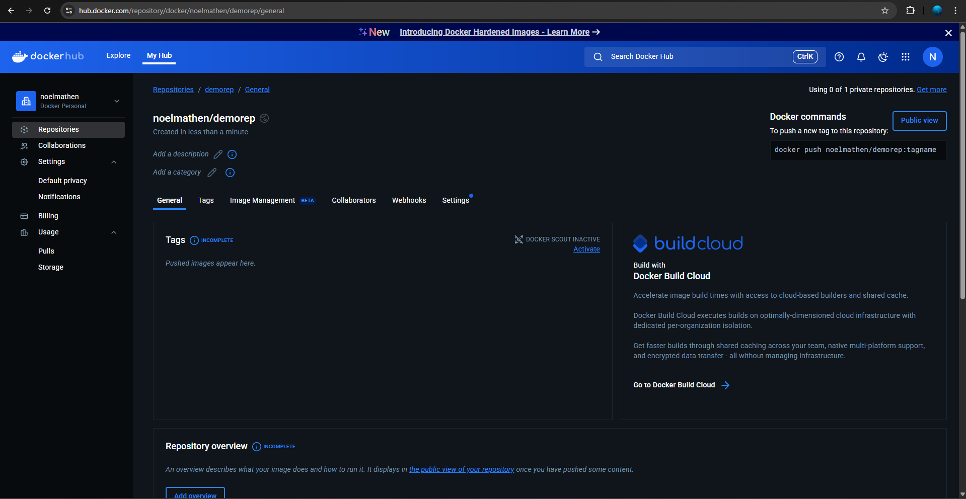

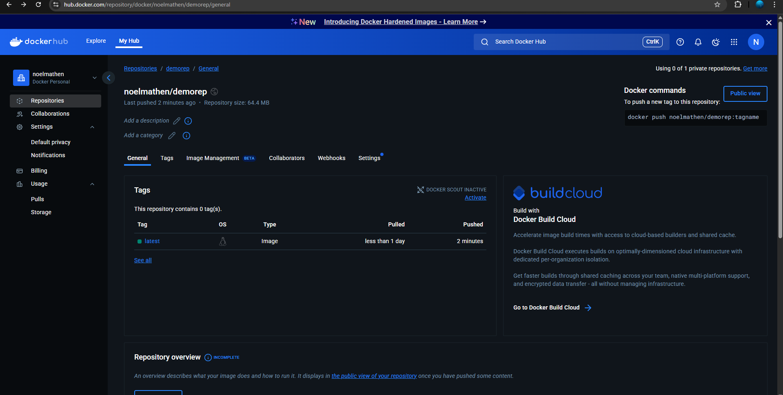

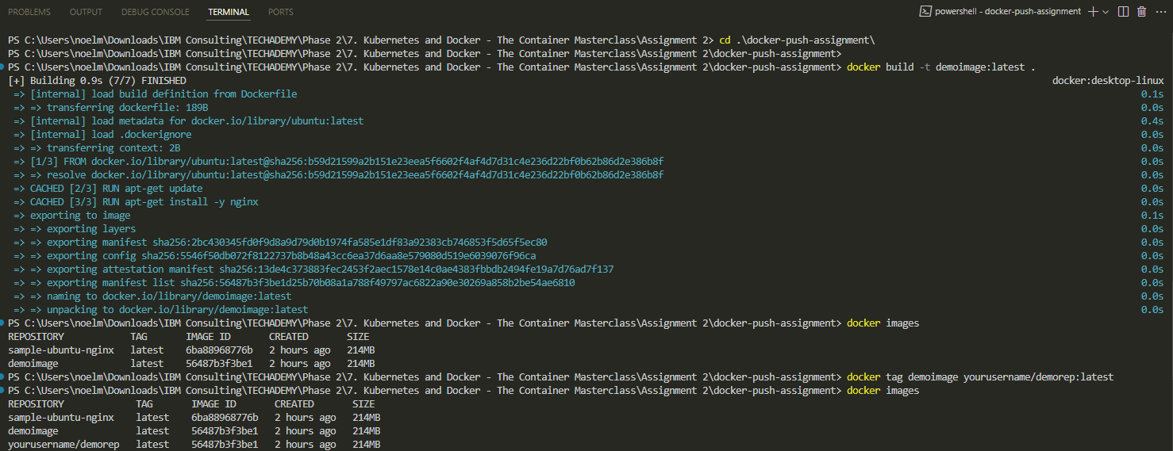

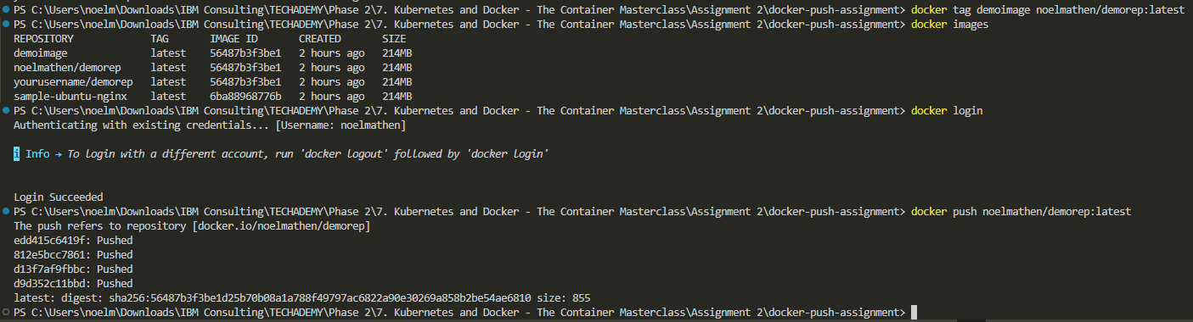

DockerFile:

# Dockerfile

FROM ubuntu

LABEL *maintainer=*"yourname@domain.com"

RUN *apt-get* *update*

RUN *apt-get* *install* *-y* *nginx*

CMD *[*"echo"*,* "Image created"*]*